# Data Analysis and Chart Creation in Excel Exercises

## Which are the top 3 of best selling products?

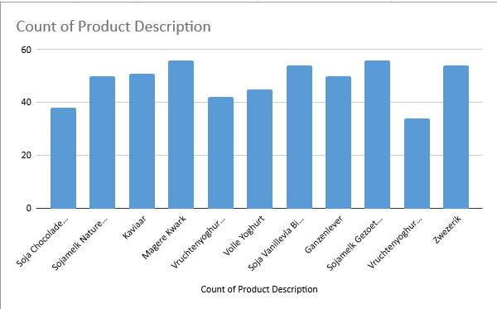

* Magere Kwark
* Sojamelk Gezoet Biologisch
* Zwezerik

## What was total sales in 2013?

## What was the turnover for every region in 2012?

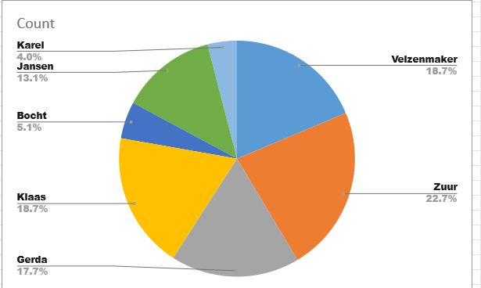

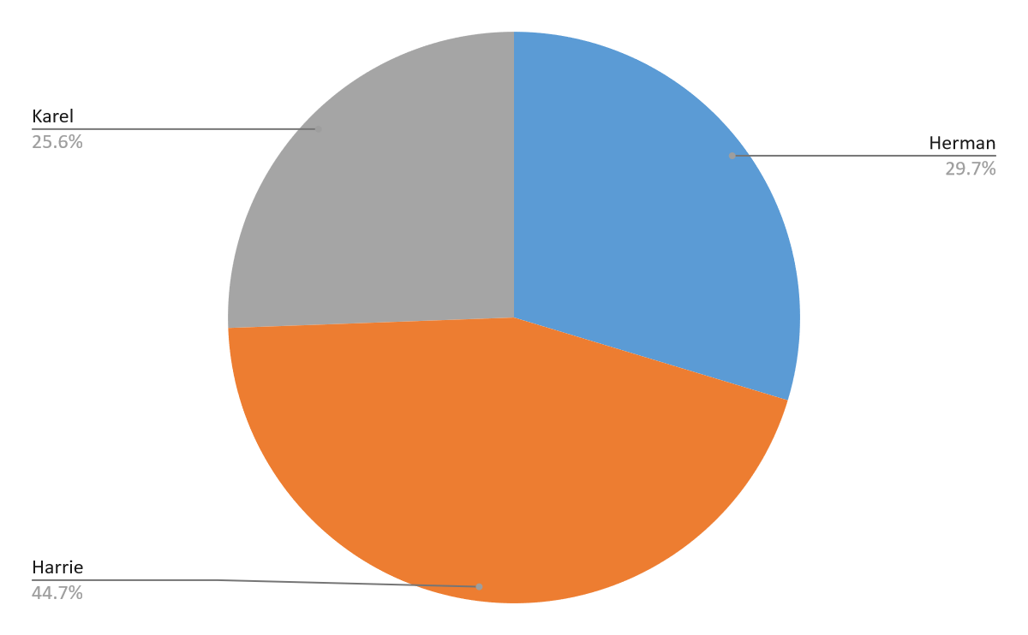

## Who is the best selling salesperson?

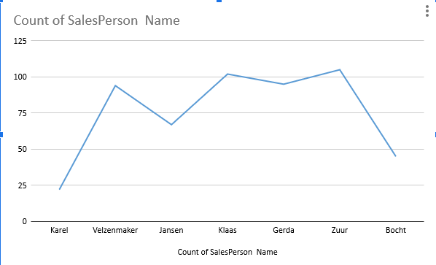

## How many articles have been sold per product category?Chart

## What is the average turnover per order?

* 239.3253774

## How many orders are there in January 2013 for region code “GVGH

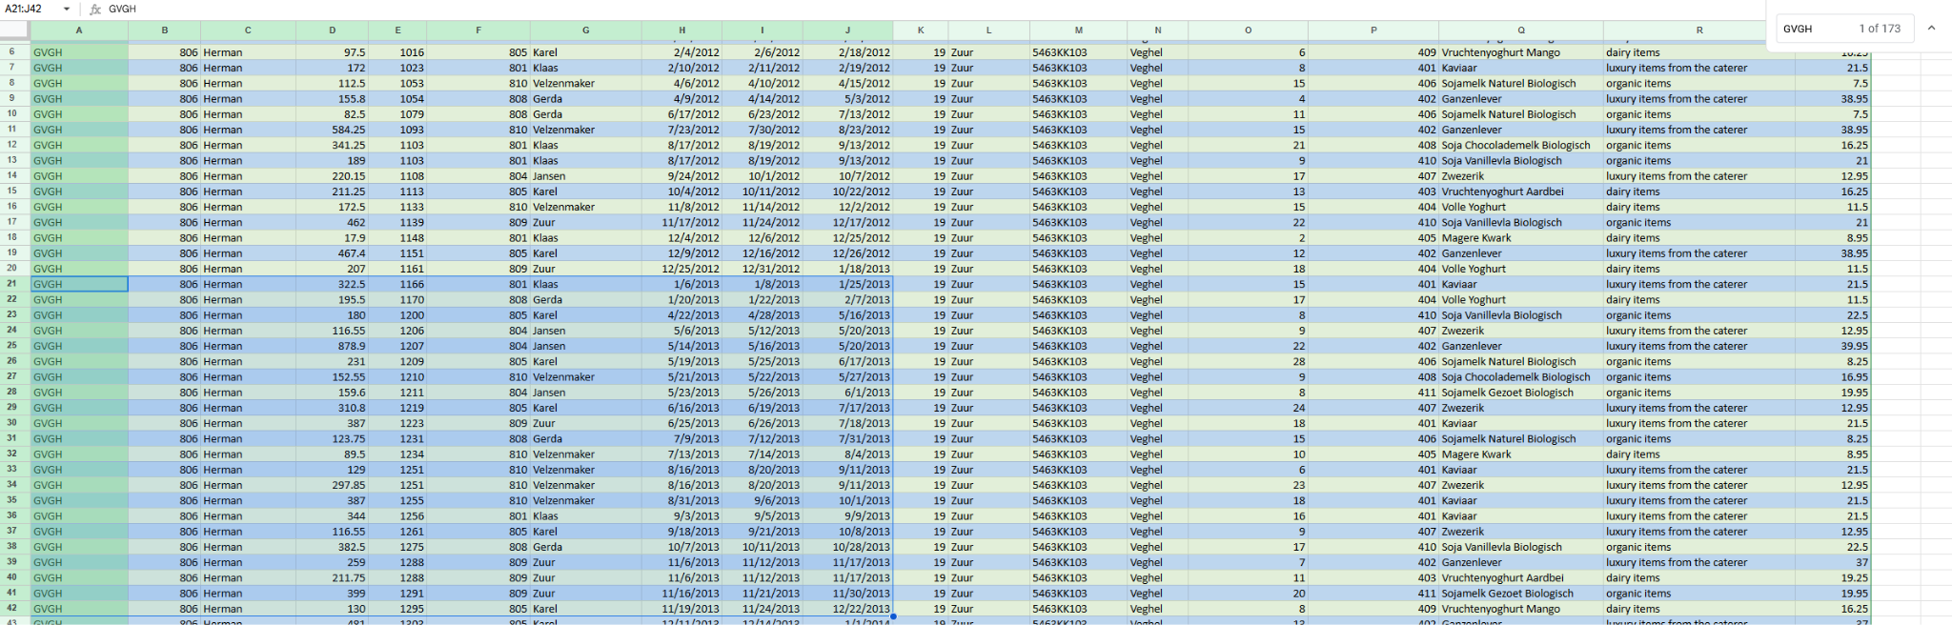

* 21 for 2013 or 2 for Jan.